

**Aspose for Cloud**

REST APIs for Word

Version 1.0

***Installation Guide***

**Revision History**

|  |  |  |
| --- | --- | --- |
| Revision | Date | Comments |
| 1.0 | 07-Aug-2016 | This version of the guide includes the instructions to deploy the Cloud APIs for Word version 1.0 and to verify the deployment. |

Contents

1. Introduction 4

2. Purpose 4

3. Scope 4

4. Download the Solution 4

5. Build the Code 5

6. Publish APIs to IIS 5

7. Verify the Publishing 6

# Introduction

Aspose Word REST APIs for Cloud version 1.0 is being launched with the intention of enabling the people to manipulate some basic features of Microsoft without installing MS Office or any other software. They only need a web browser and rest of things will be taken care of by Aspose.

# Purpose

Purpose of this guide is to enable the technical personnel to download the code of Aspose Word REST APIs for Cloud, compile it and deploy it on the server. Further to that it should also direct him/her about the verification of successful deployment.

# Scope

This document is intended to provide the instructions for deploying the web API and not meant for supplying any implementation details of them. Developers or any other technical people interested in knowing the technical details of design should consult ***Design Guide***.

# Download the Solution

You can download the complete solution from the following link:

[*https://github.com/faisaljarral/aspose*](https://github.com/faisaljarral/aspose)

A screen similar to the following will appear:

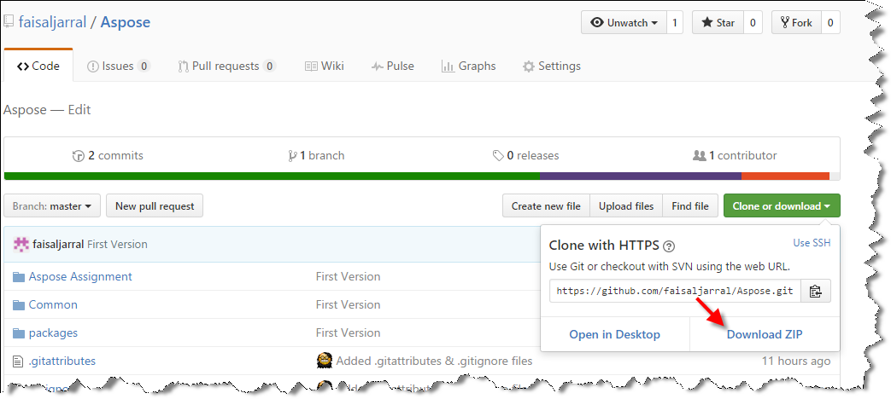

You can download the solution in form of zip file and extract it on your machine.

# Build the Code

This is the ASP.Net solution hence Microsoft Visual Studio can be used to open it. For this purpose you can either open the solution file “.sln” by double clicking it or run visual studio and open it using ***FILE🡪Open Project*** menu.

Once the solution is open it can be built using ***BUILD🡪Build Solution*** option or ***Ctrl+Shift+B*** can also be used for this purpose. Alternatively you can right click the solution in Solution Explorer and choose Build Solution option from popup menu.

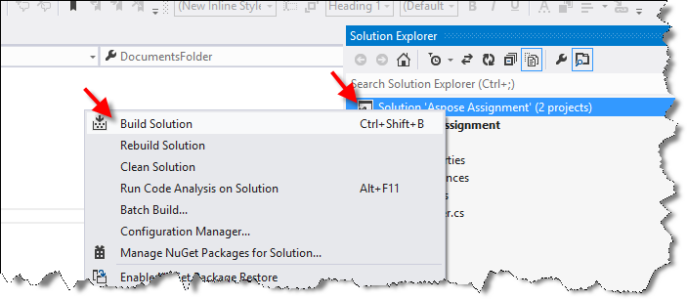

# Publish APIs to IIS

For publishing APIs to IIS you need to choose the Aspose Assignment project under solution. Upon right clicking it a popup will appear containing Publish option. Once you will select this option a wizard similar to the below mentioned will popped up:

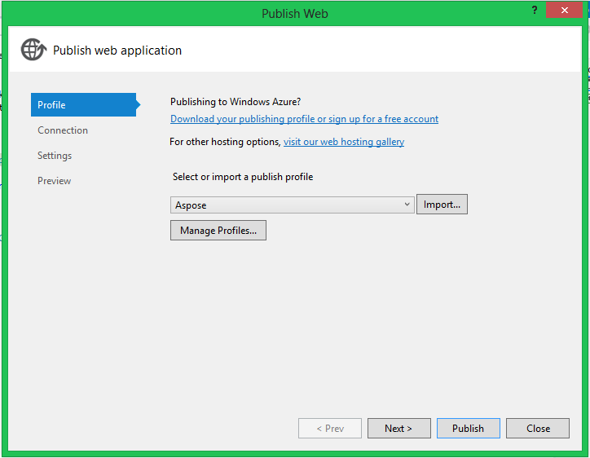

Keep selecting the appropriate values on every step till you reach the **Preview** step where you should click the Publish button. This will publish the APIs to the IIS web server. Now these are available to consume.

# Verify the Publishing

We have provided a couple of simple html pages with the APIs to verify if the APIs are working as per expected? All you have to run any web browser like Chrome and type an address something like the below mentioned and hit enter:

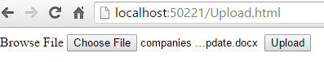

Address prior to the html page could be different and it will depend on the domain name (or port) assigned to the APIs.

Once you have chosen a document and Upload it using this page you can verify the other API operations using Process.html page that should be looking like the following:

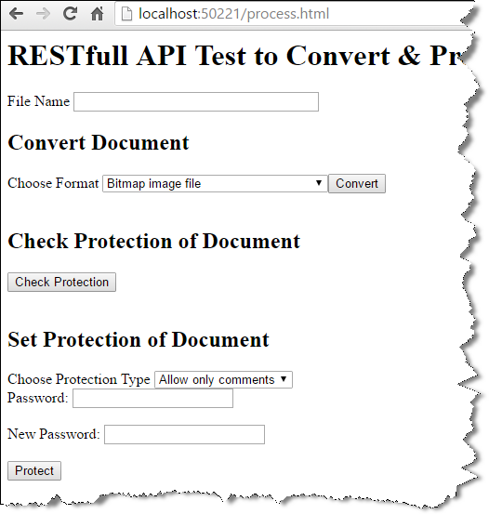

You can verify the Convert API by following the steps listed below:

1. Punch the name of file (just uploaded in previous step) against the field **File Name**.
2. Choose the desired format.
3. Click the **Convert** button.
4. A message will be appeared where you can also find the link of newly created document. You can download it and see if it is correct.

Protection API can be tested using the following steps:

1. Enter the name of file in **File Name** box, you want to operate for protection.
2. Click the Check Protection button to see the protection currently applied to the document.
3. You can also apply various protection options on the document by selecting it against **Choose Protection Type** list and click **Protect** button.
4. You can also apply a password on the document or change an existing one by typing it against **New Password** box.
5. Password can be cleared by leaving **New Password** field empty.

END